EXPERIMENT – 3
AIM:
To create an Employee–Department–Project database schema, insert at least 30 employees across 5 departments and 8 projects, and perform SQL queries demonstrating Selection, Projection, Aggregate Functions, GROUP BY, HAVING, CASE expressions, and ORDER BY.

SOURCE CODE:

1. Create Database Tables:
-- Create Department table
CREATE TABLE Department (
dept_id INT PRIMARY KEY,
dept_name VARCHAR(50) NOT NULL,
location VARCHAR(50)
);

-- Create Project table
CREATE TABLE Project (
project_id INT PRIMARY KEY,
project_name VARCHAR(100) NOT NULL,
budget DECIMAL(12,2)
);

-- Create Employee table
CREATE TABLE Employee (
emp_id INT PRIMARY KEY,
emp_name VARCHAR(50) NOT NULL,
salary DECIMAL(10,2),
dept_id INT,
project_id INT,
joining_date DATE,
FOREIGN KEY (dept_id) REFERENCES Department(dept_id),
FOREIGN KEY (project_id) REFERENCES Project(project_id)
);

2. Insert Data into Department Table:
INSERT INTO Department VALUES
(1, 'Computer Science', 'Chandigarh'),
(2, 'Artificial Intelligence', 'Delhi'),
(3, 'Human Resources', 'Mumbai'),
(4, 'Finance', 'Bangalore'),
(5, 'Marketing', 'Pune');

3. Insert Data into Project Table:
INSERT INTO Project VALUES
(101, 'AI Chatbot', 1500000),
(102, 'E-Commerce Portal', 2200000),
(103, 'Banking System', 3000000),
(104, 'Healthcare App', 1800000),
(105, 'Cloud Migration', 2500000),
(106, 'Cyber Security', 2000000),
(107, 'Marketing Analytics', 1200000),
(108, 'Employee Management', 1000000);

4. Insert 30 Employees:
INSERT INTO Employee VALUES
(1, 'Aarav Sharma', 65000, 1, 101, '2023-01-10'),
(2, 'Riya Verma', 72000, 1, 102, '2022-03-15'),
(3, 'Aditya Singh', 58000, 1, 103, '2023-06-20'),
(4, 'Ananya Gupta', 81000, 1, 104, '2021-08-12'),
(5, 'Karan Mehta', 69000, 1, 105, '2022-11-05'),
(6, 'Priya Sharma', 75000, 1, 106, '2023-02-18'),

(7, 'Arjun Kapoor', 85000, 2, 101, '2021-04-10'),
(8, 'Sneha Jain', 92000, 2, 102, '2022-05-14'),
(9, 'Rahul Malhotra', 78000, 2, 103, '2023-01-22'),
(10, 'Ishita Roy', 88000, 2, 104, '2022-09-17'),
(11, 'Varun Gupta', 95000, 2, 105, '2021-12-11'),
(12, 'Neha Kapoor', 83000, 2, 106, '2023-07-01'),

(13, 'Manish Kumar', 55000, 3, 108, '2022-02-10'),
(14, 'Kavya Singh', 62000, 3, 108, '2023-03-15'),
(15, 'Rohit Sharma', 58000, 3, 107, '2022-07-19'),
(16, 'Pooja Verma', 67000, 3, 108, '2021-10-05'),
(17, 'Nikhil Jain', 60000, 3, 107, '2023-05-21'),
(18, 'Simran Kaur', 64000, 3, 108, '2022-12-09'),

(19, 'Vikas Agarwal', 88000, 4, 103, '2021-06-11'),
(20, 'Megha Gupta', 76000, 4, 103, '2022-04-25'),
(21, 'Sahil Bansal', 91000, 4, 105, '2021-09-18'),
(22, 'Tanvi Shah', 72000, 4, 107, '2023-01-30'),
(23, 'Mohit Arora', 84000, 4, 103, '2022-08-14'),
(24, 'Divya Mehta', 79000, 4, 105, '2023-04-16'),

(25, 'Akash Yadav', 60000, 5, 107, '2022-01-12'),
(26, 'Shreya Kapoor', 68000, 5, 107, '2023-02-20'),
(27, 'Varun Sharma', 73000, 5, 102, '2021-11-08'),
(28, 'Aditi Singh', 65000, 5, 104, '2022-06-13'),
(29, 'Harsh Gupta', 71000, 5, 107, '2023-03-22'),
(30, 'Muskan Jain', 69000, 5, 102, '2022-10-10');

5. SELECTION:

Display employees whose salary is greater than ₹80,000.
SELECT *
FROM Employee
WHERE salary > 80000;

Output:
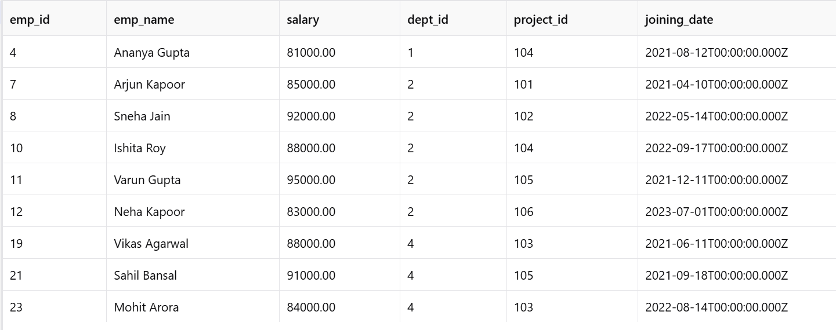

6. PROJECTION:

Display only employee names and their salaries.
SELECT emp_name, salary
FROM Employee;

Output:
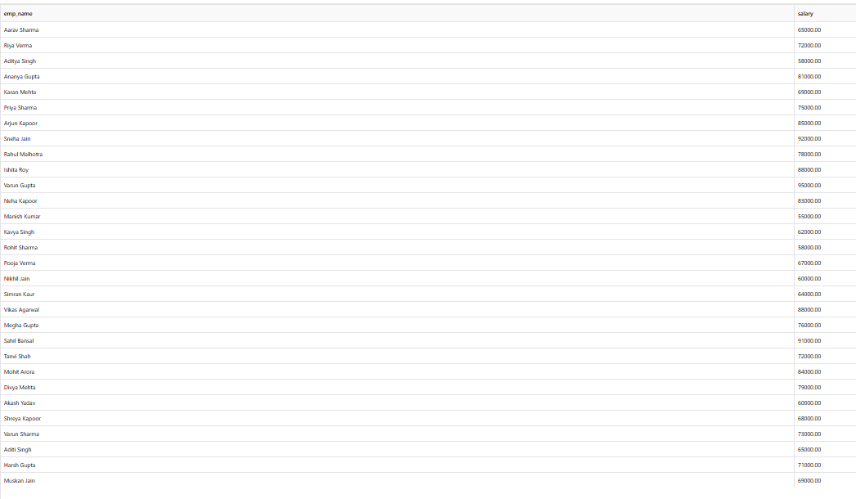

7. AGGREGATE FUNCTIONS:

Find the total, average, maximum and minimum salary.
SELECT
SUM(salary) AS total_salary,
AVG(salary) AS average_salary,
MAX(salary) AS maximum_salary,
MIN(salary) AS minimum_salary
FROM Employee;

Output:

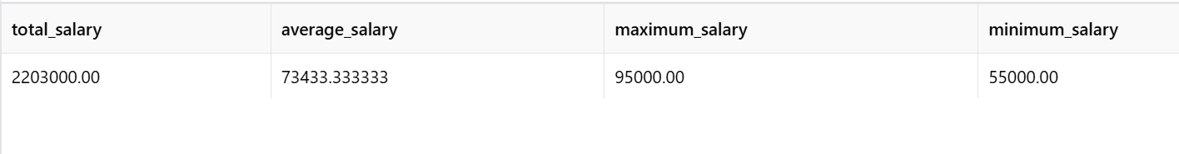

8. GROUP BY:

Find the number of employees in each department.
SELECT
dept_id,
COUNT(*) AS total_employees
FROM Employee
GROUP BY dept_id;

Output:
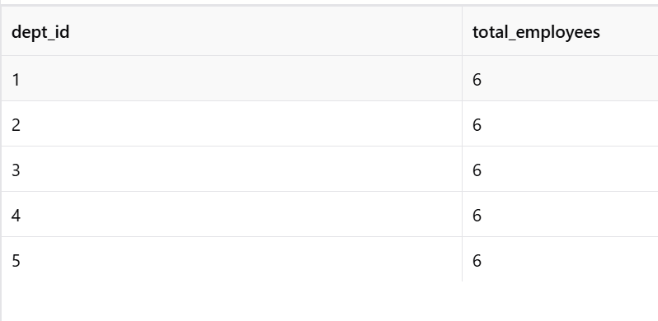

9. GROUP BY WITH JOIN:

Display department name and average salary of each department.
SELECT
d.dept_name,
AVG(e.salary) AS average_salary
FROM Employee e
JOIN Department d
ON e.dept_id = d.dept_id
GROUP BY d.dept_name;

Output:

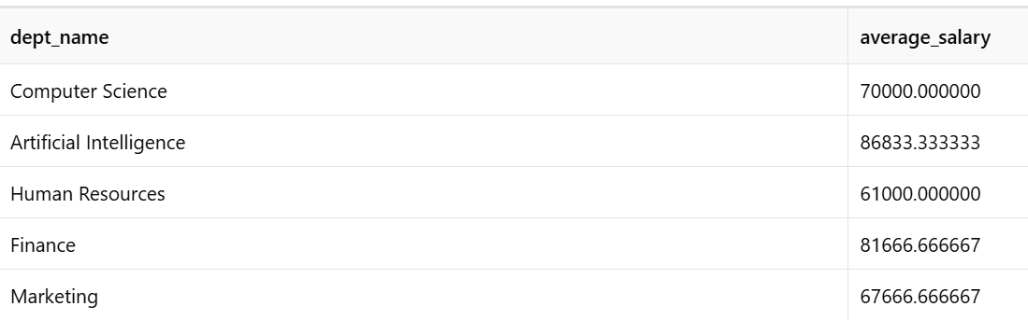

10. HAVING:

Display departments having an average salary greater than ₹70,000.
SELECT
d.dept_name,
AVG(e.salary) AS average_salary
FROM Employee e
JOIN Department d
ON e.dept_id = d.dept_id
GROUP BY d.dept_name
HAVING AVG(e.salary) > 70000;

Output:
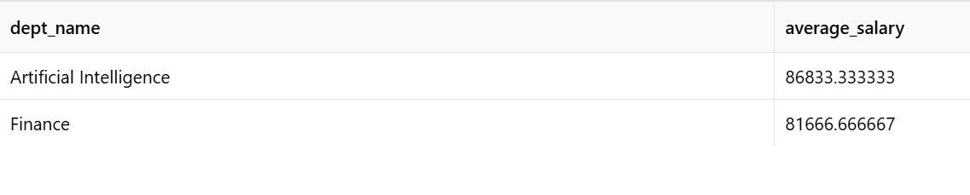

11. CASE EXPRESSION:

Categorize employees according to their salary.
SELECT
emp_name,
salary,
CASE
WHEN salary >= 85000 THEN 'High Salary'
WHEN salary >= 70000 THEN 'Medium Salary'
ELSE 'Low Salary'
END AS salary_category
FROM Employee;

Output:

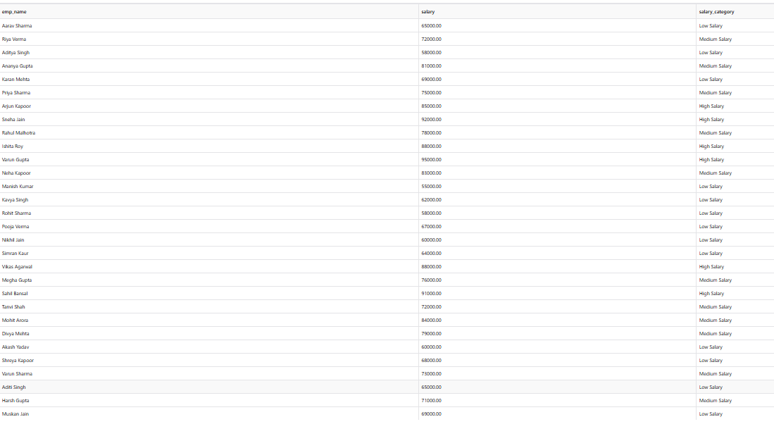

12. ORDER BY:

Display employees in descending order of salary.
SELECT
emp_id,
emp_name,
salary
FROM Employee
ORDER BY salary DESC;

Output:
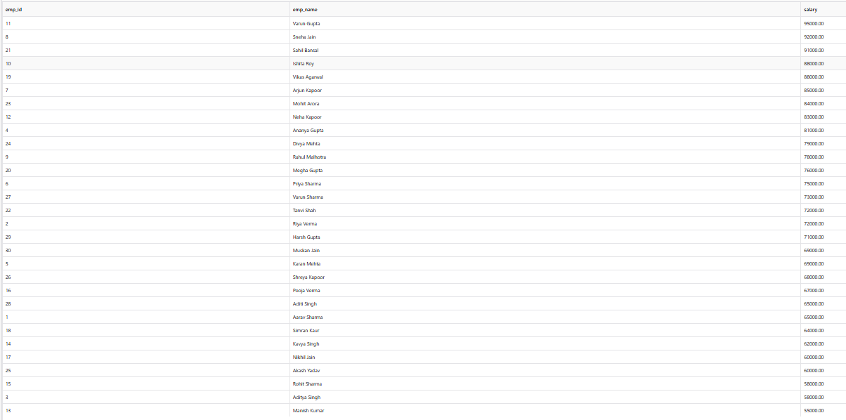

13. PROJECT-WISE EMPLOYEE COUNT:

Find the number of employees working on each project.
SELECT
p.project_name,
COUNT(e.emp_id) AS total_employees
FROM Project p
LEFT JOIN Employee e
ON p.project_id = e.project_id
GROUP BY p.project_name
ORDER BY total_employees DESC;

Output:
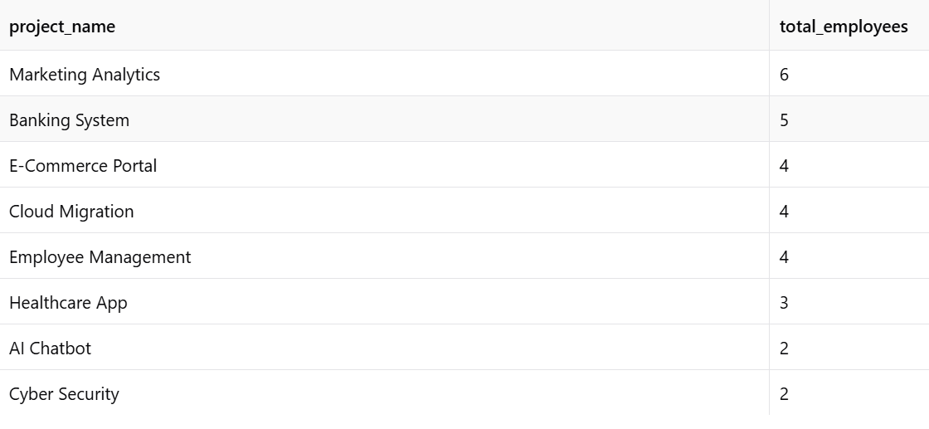

14. COMBINED QUERY:

Display employee name, department, project and salary in descending order of salary.
SELECT
e.emp_name,
d.dept_name,
p.project_name,
e.salary
FROM Employee e
JOIN Department d
ON e.dept_id = d.dept_id
JOIN Project p
ON e.project_id = p.project_id
ORDER BY e.salary DESC;

Output:
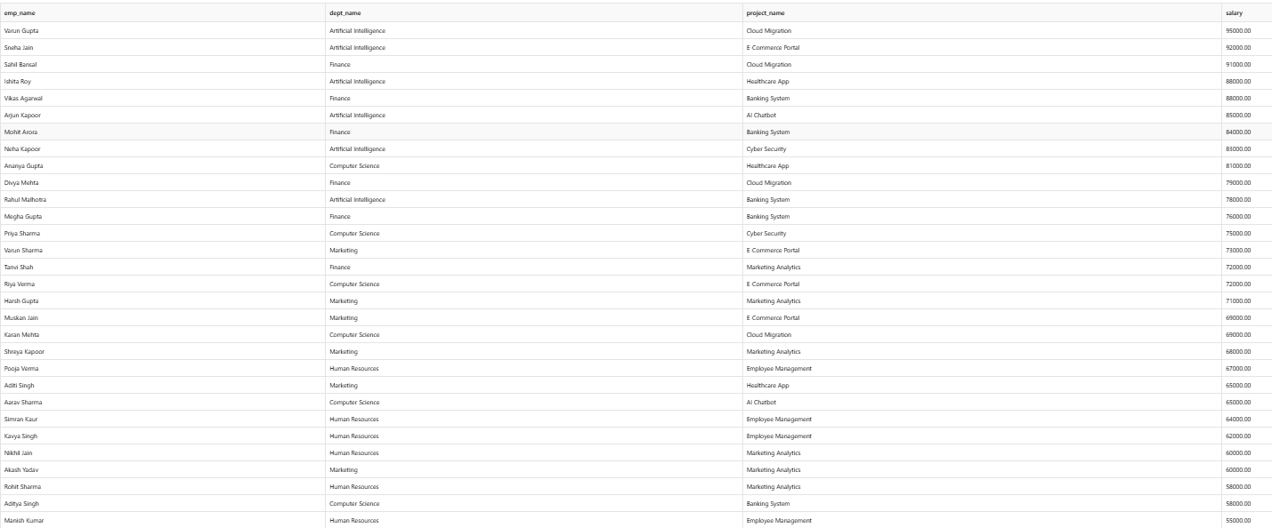

RESULT:
The Employee–Department–Project database schema was successfully created with 30 employees, 5 departments, and 8 projects. SQL queries demonstrating Selection, Projection, Aggregate Functions, GROUP BY, HAVING, CASE expressions, and ORDER BY were successfully executed and their outputs were obtained.

